# The Nitrogen Cycle

|  |  |
| --- | --- |
| Name: |  |
| Class: |  |
| Period: |  |
| Date: |  |

Carefully read each question and then circle the letter of the correct answer.

1. Recall the percentage of the atmosphere that nitrogen makes up.
   1. 11%
   2. 21%
   3. 56%
   4. 78%
2. Select the best description of nitogen fixation.
   1. The conversion of nitrogen gas from the atmosphere into nitrates, that plants can then assimilate.
   2. The conversion of nitrogen gas from the atmosphere into ammonium, a more usable form.
   3. The conversion of nitrates into molecules like DNA proteins that remain in a plant or animal until it dies.
3. Recall the natural process capable of nitrogen fixation.
   1. Fire
   2. Strong winds
   3. Lightning
   4. Tornadoes
4. Legume plants are an interesting case in the nitrogen cycle, as they are capable of absorbing ammonium for use, instead of waiting for nitrites and nitrates to be formed.

Recall the source of their ammonium.Select the option that best justifies your reasoning.

* 1. They have bacteria attached to their roots which fix the nitrogen for them.
  2. They propduce lightning strikes that fix the nitrogen.
  3. They decompose the organic nitrogen compounds in dead material.
  4. They produce it through photosynthesis.

1. Identify what nitrogen is used for in living organisms.
   1. Building sugars and starches
   2. Energy for the brain and muscles
   3. Building DNA and proteins.
2. Kōwhai (Sophora spp.) are plants that are native to Aotearoa/New Zealand, and an example of a legume. Some species are very good at growing in rocky and infertile soils, which often have low levels of nitrogen.
   1. Kōwhai are lgumes which contain nitrogen-fixing bacteria in their root nodules.
   2. Kōwhai are native to New Zealand and do not need as much nitrogen as introduced species of plants.
   3. Kōwhai are legumes which produce their own nitrogen during photosynthesis.
3. Agriculture is a huge industry in both Australia and New Zealand. Synthetic nitrogen fertilisers are applied to soil in order to grow crops to feed people or livestock. Usually the nitrogen from the fertiliser is added in excess (more than is needed).

Select what happens to the majority of the excess nitrogen in the soil.

* 1. The excess nitrogen undergoes denitrification and is returned to the atmosphere as nitrogen gas.
  2. The excess nitrogen dissolves in rain water and then runs off into nearby waterways.
  3. The excess nitrogen is broken doen into other useful compounds by decomposers.

1. Which of the following human activities has caused the most significant imbalance in the Earth’s nitrogen cycle?
   1. The cultivation of nitrogen-fixing crops
   2. The use of synthetic nitrogen fertilisers in agriculture
   3. The release of nitrogen-containing gases from landfills.
2. Select all of the options that could reduce the amount of nitrogen-rich effluent that flows into waterways. Select ALL correct options
   1. Reducing food waste
   2. Improving nitrogen efficiency in fertilisers
   3. Eating less beef and dairy
   4. Transporting synthetic fertilisers to countries that need it most
3. **This question has two parts. Make sure you answer both.**

Aotearoa/New Zealand relies heavily on its agricultural industry. In 2017, approximately 450,000 tonnes of nitrogen fertiliser was used on New Zealand farms. The graph below shows the percentage of this nitrogen fertiliser that was used in the different farming sectors.

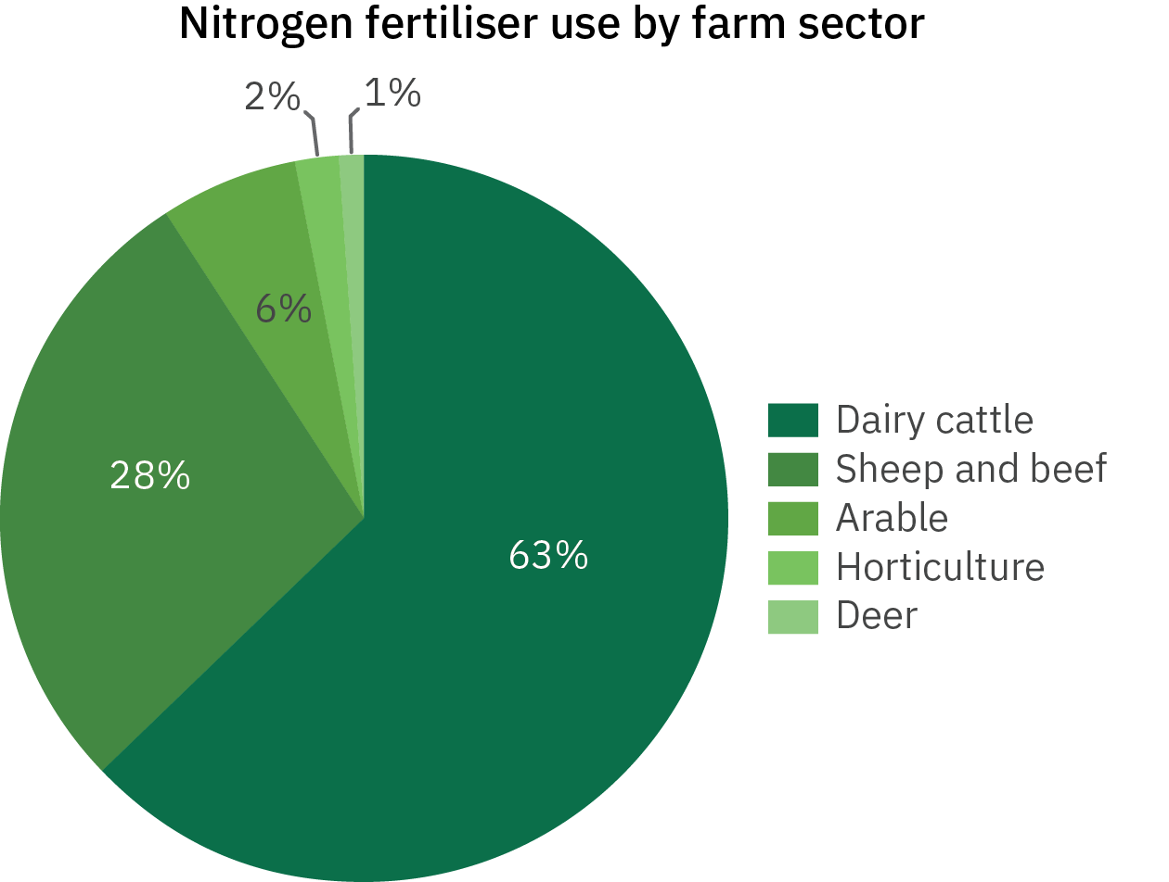

From the graph, identify the type of farming that uses the most nitrogen fertiliser.

1. Deer
2. Arable
3. Dairy Cattle
4. Horticulture
5. Sheep and beef

Based on your answer above, determine which food products have the greatest impact on the nitrogen cycle in New Zealand.

1. Milk and cheese
2. Bread and cereal
3. Fruits and vegetables
4. Beef and Lamb

Select the correct words to fill in the spaces below.

**Nitrogen gas Nitrogen fixation Nitrification Ammonium Nitrates**

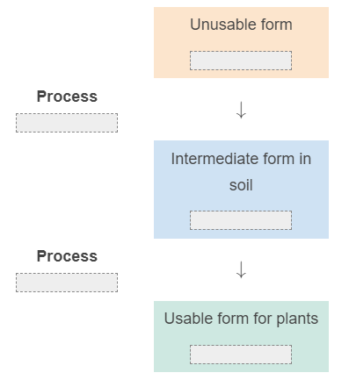

**Nitrogen gas (N2) Ammonia (NH3) Nitrifying bacteria Organic waste material Nitrogen-fixing bacteria Denitrifying bacteria Ammonia (NH3)**

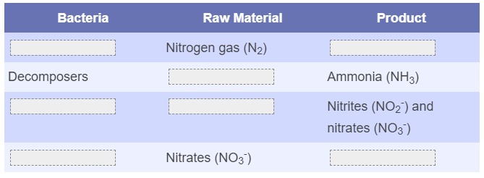

**oxygen photosynthesis algae decomposition**

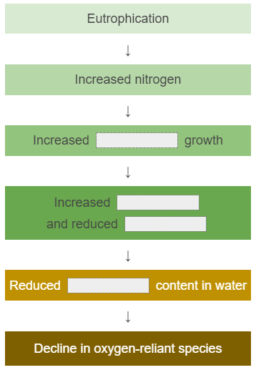

Annotation

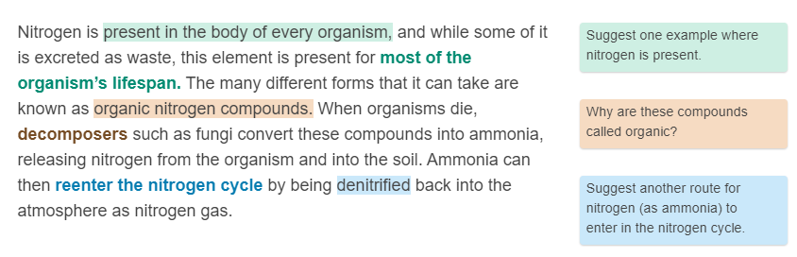**Read the passage below and aswer the corresponding questions.**

Short Answer

1. White clover (Trifolium repens) is an important legume that many farmers grow in their pastures to help improve the growth of other plants.

Describe the relationship between the clover plant and Rhizobia bacteria, and how it benefits both organisms.

*Be sure to refer to nitrogen cycle processes in your answer.*

1. **This question has two parts. Make sure you answer them both.**

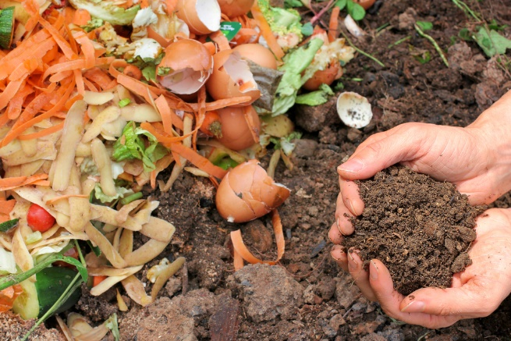Olivia lives in a house with a compost bin where her family usually throws their food scraps. The food scraps break down into compost that they can then use to fertilise their garden.

Olivia loves buying leafy greens like spinach for her salads and smoothies, but she often doesn’t eat it all before it goes off.

Below are three possible actions Olivia could take. All of these actions affect the nitrogen cycle in some way.

**Order these actions from best (1) to worst (3) in terms of their effects on the nitrogen cycle.**

Reduce the amount of spinach she buys, so that less nitrogen fertiliser is used to grow food that isn’t eaten.

Throw the spinach into the compost bin, so the nitrogen it contains can be broken down and added back into the soil of her garden.

Throw the spinach into the rubbish bin, where it will end up in the landfill and break down to release nitrogen gas back into the atmosphere.

(Best) 1.

2.

(Worst) 3.

Glossary

**Decomposition Denitrification Nitrogen Fixation Nitrification**

